COMPETETIVE PROGRAMMING PROBLEMS

1. Find Duplicate in Array.

Given a read only array of n integers between 1 and n, find one number that repeats.

Input Format:

First Line - Number of elements

n Lines - n Elements

Output Format:

Element x - That is repeated

**For example:**

| **Input** | **Result** |
| --- | --- |
| 5  1 1 2 3 4 | 1 |

Program: #include <stdio.h>

int main () {

int a;

scanf("%d",&a);

int arr[a];

for (int i=0;i<a;i++){

scanf("%d",&arr[i]);

}

for (int j=0;j<a;j++){

for (int k=0;k<j;k++){

if (arr[j]==arr[k]){

printf("%d",arr[j]);

break;

}

}

}

}

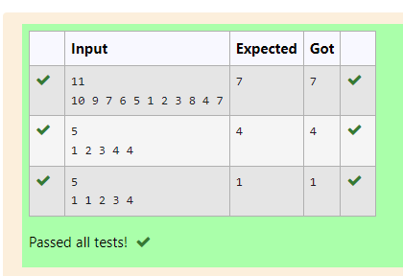

2. Find Duplicate in Array.

Given a read only array of n integers between 1 and n, find one number that repeats.

Input Format:

First Line - Number of elements

n Lines - n Elements

Output Format:

Element x - That is repeated

**For example:**

| **Input** | **Result** |
| --- | --- |
| 5  1 1 2 3 4 | 1 |

PROGRAM :  
#include <stdio.h>

int main () {

int a,b,c;

scanf("%d",&a);

int arr[a];

for (int i=0;i<a;i++){

scanf("%d",&arr[i]);

}

int sum=0;

for (int i=0;i<a;i++){

sum+=arr[i];

}

b=((a)*(a-1))/2;

c=sum-b;

printf("%d",c);

}

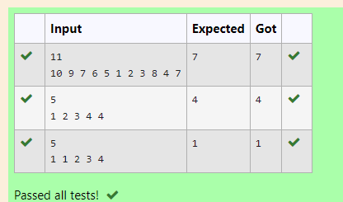

3. Find the intersection of two sorted arrays.

OR in other words,

Given 2 sorted arrays, find all the elements which occur in both the arrays.

Input Format

·       The first line contains T, the number of test cases. Following T lines contain:

1.     Line 1 contains N1, followed by N1 integers of the first array

2.     Line 2 contains N2, followed by N2 integers of the second array

Output Format

The intersection of the arrays in a single line

Example

Input:

1

3 10 17 57

6 2 7 10 15 57 246

Output:

10 57

Input:

1

6 1 2 3 4 5 6

2 1 6

Output:

1 6

**For example:**

| **Input** | **Result** |
| --- | --- |
| 1  3 10 17 57  6  2 7 10 15 57 246 | 10 57 |

PROGRAM:

#include<stdio.h>

int main(){

int k;scanf("%d",&k);

while(k!=0){k--;

int a,b;scanf("%d",&a);

int arr[a];

for(int i=0;i<a;i++)scanf("%d",&arr[i]);

scanf("%d",&b);

int brr[b];

for(int i=0;i<b;i++)scanf("%d",&brr[i]);

for(int i=0;i<a;i++){

for(int j=0;j<b;j++){

if(arr[i]==brr[j]){

printf("%d ",arr[i]);

break;}}}}}

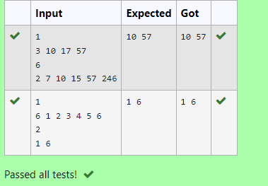

4. Find the intersection of two sorted arrays.

OR in other words,

Given 2 sorted arrays, find all the elements which occur in both the arrays.

Input Format

·       The first line contains T, the number of test cases. Following T lines contain:

1.     Line 1 contains N1, followed by N1 integers of the first array

2.     Line 2 contains N2, followed by N2 integers of the second array

Output Format

The intersection of the arrays in a single line

Example

Input:

1

3 10 17 57

6 2 7 10 15 57 246

Output:

10 57

Input:

1

6 1 2 3 4 5 6

2 1 6

Output:

1 6

**For example:**

| **Input** | **Result** |
| --- | --- |
| 1  3 10 17 57  6  2 7 10 15 57 246 | 10 57 |

#include<stdio.h>

int main(){

int k;scanf("%d",&k);

while(k!=0){k--;

int a,b;scanf("%d",&a);

int arr[a];

for(int i=0;i<a;i++)scanf("%d",&arr[i]);

scanf("%d",&b);

int brr[b];

for(int i=0;i<b;i++)scanf("%d",&brr[i]);

int i=0,j=0;

while(i<a&&j<b){

if(arr[i]==brr[j]){

printf("%d ",arr[i]);

i++;j++;}

else if(arr[i]<brr[j])i++;

else j++;}}}

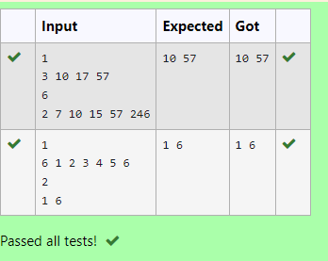

5. Given an array A of sorted integers and another non negative integer k, find if there exists 2 indices i and j such that A[j] - A[i] = k, i != j.

Input Format:

First Line n - Number of elements in an array

Next n Lines - N elements in the array

k - Non - Negative Integer

Output Format:

1 - If pair exists

0 - If no pair exists

Explanation for the given Sample Testcase:

YES as 5 - 1 = 4

So Return 1.

PROGRAM:

#include <stdio.h>

int main(){

int a;scanf("%d", &a);

int arr[a];

for(int i=0;i<a;i++)scanf("%d", &arr[i]);

int c=0,k;scanf("%d", &k);

for(int i=0;i<a;i++){

for(int j=i+1;j<a;j++){

if(arr[j]-arr[i]==k){c=1;break;}}}

printf("%d\n",c);}

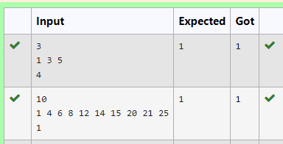

6. Given an array A of sorted integers and another non negative integer k, find if there exists 2 indices i and j such that A[j] - A[i] = k, i != j.

Input Format:

First Line n - Number of elements in an array

Next n Lines - N elements in the array

k - Non - Negative Integer

Output Format:

1 - If pair exists

0 - If no pair exists

Explanation for the given Sample Testcase:

YES as 5 - 1 = 4

So Return 1.

PROGRAM#include <stdio.h>

int main(){

int a;scanf("%d", &a);

int arr[a];

for(int i=0;i<a;i++)scanf("%d", &arr[i]);

int c=0,k;scanf("%d", &k);

int i=0,j=1;

while(j<a){

int d=arr[j]-arr[i];

if (d==k&&i!=j){

c=1;break;}

else if(d<k)j++;

else i++;}

if(c==1)printf("1");

else printf("0");

}

